Testing of Developed Website
“Google lighthouse” testing tool is used to test the developed website.Google Lighthouse is a tool developed by Google that helps web developers to test the web-pages for improving the quality of web pages in terms of.
- Performance.
- Accessibility.
- Best Practices followed.

a. )Performance Testing:
In performance testing testing of the website the following key aspects of the site will be checked to assess the performance of the developed website.
- First contentful paint.
- First meaning paint.
- Speed index.
- Estimated Input latency.

b.)Accessibility:
- Text & Content issues:
Poor content structure.
Absolute font size.
Poor contrast.
Language Undefined.
- Common Image problems:
Missing alt attributes.
Misuse of alt text.
- Responsive Nature:
Check whether the website is compatible to various devices like notebook, mobile,etc.
- Browser compatibility.
- Easy Navigation.

c.) Best Practices:
HTML:
- Proper Document Structure.
- No inline styles.
- Use of alt attribute with images.
- Meaningful tags usage.
- Try to maintain minimum no.of.elements.
- Semantic Divisions.

CSS:
- Avoid absolute position and sizing.
- External CSS usage.
- Use generic classes.
- Combine elements.
- Top down structure.
- Make use of “em” units for fonts.
- Use multiple style sheets.
- Use shorthand.
- Appropriate naming.

INDEX PAGE-TESTING RESULTS
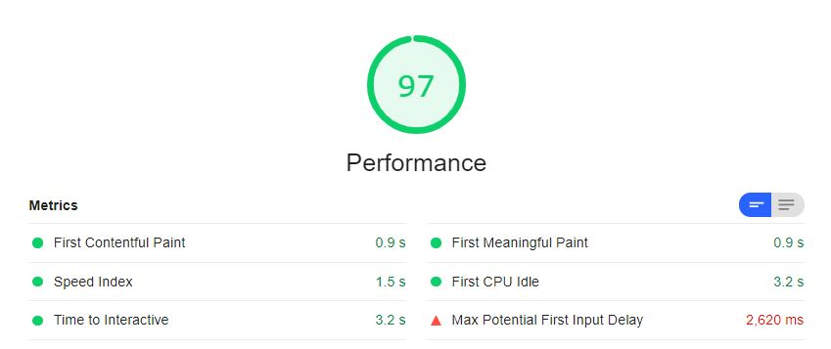

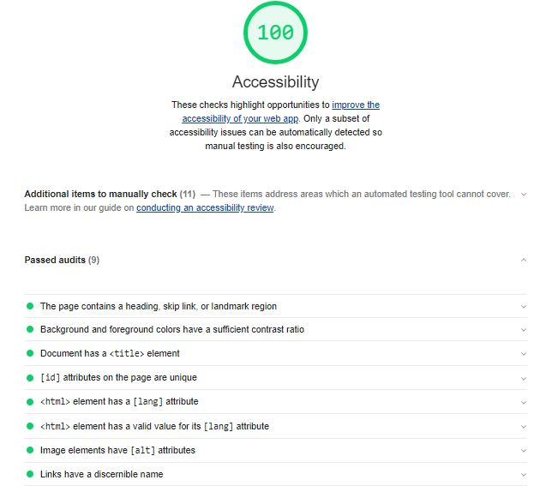

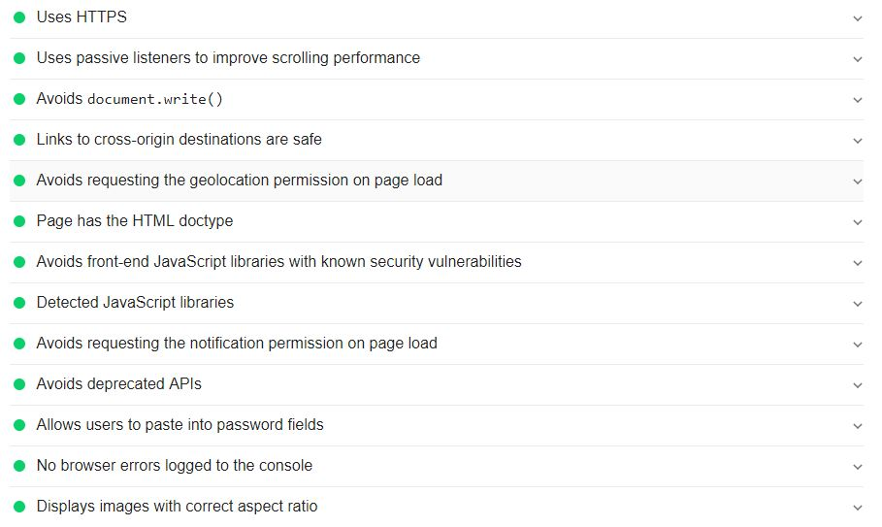

ABOUT PAGE-TESTING RESULTS
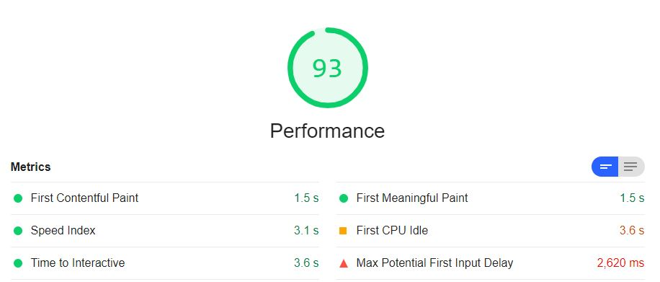
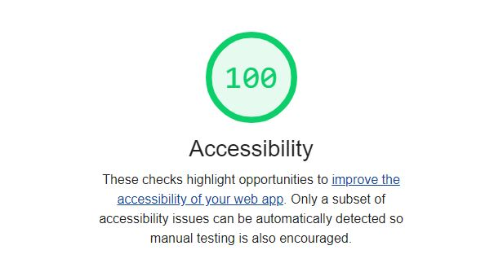
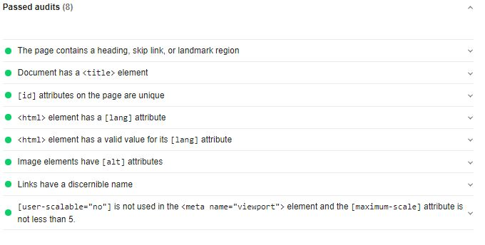

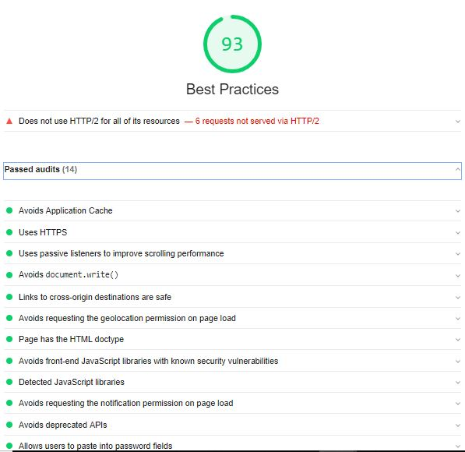

ACADEMICS PAGE-TESTING RESULTS
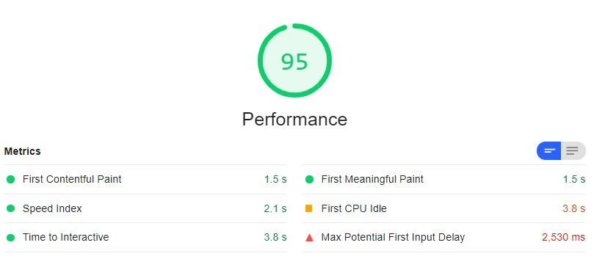

GALLERY PAGE-TESTING RESULTS
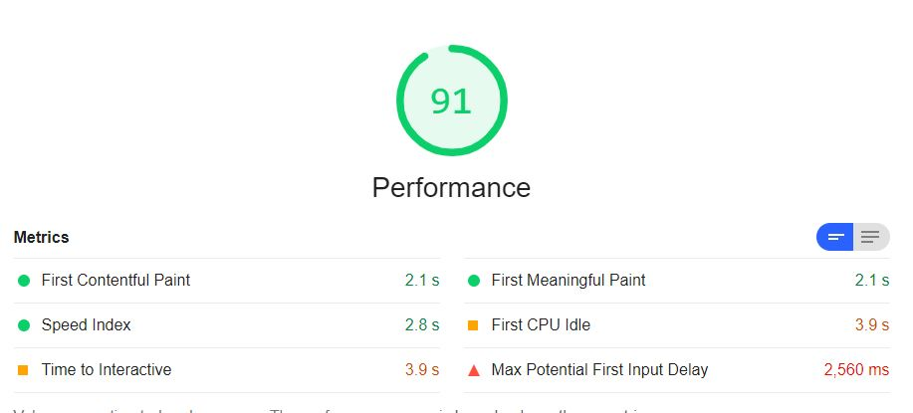
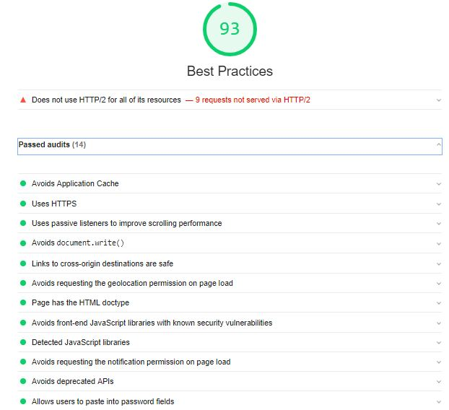

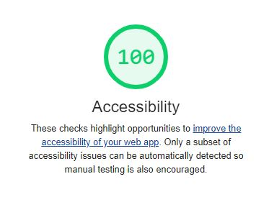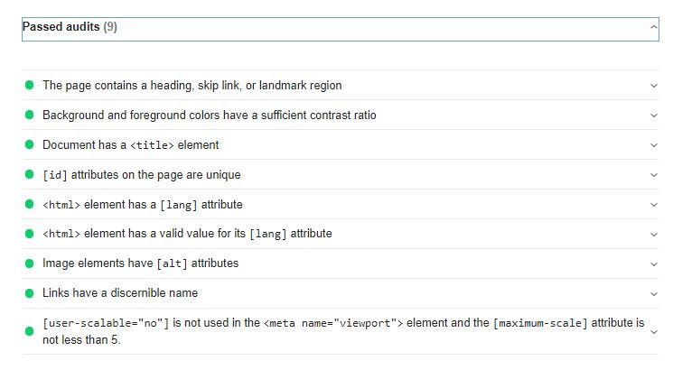
EXTRACURRICULAR PAGE-TESTING RESULTS
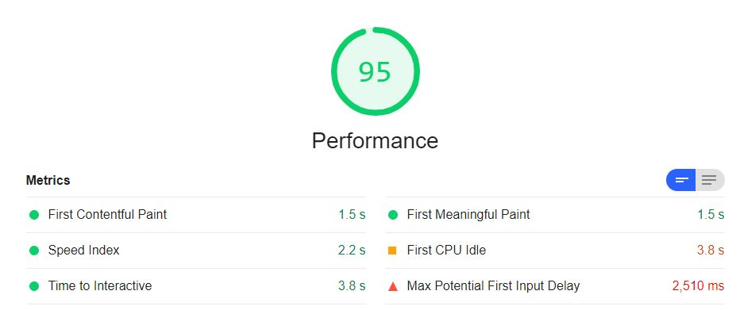

ACHIEVEMENTS PAGE-TESTING RESULTS
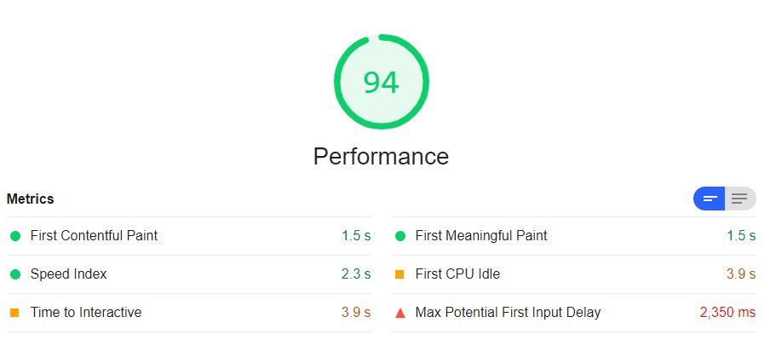
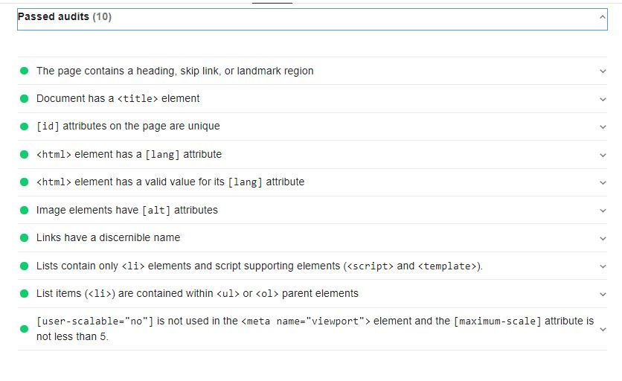
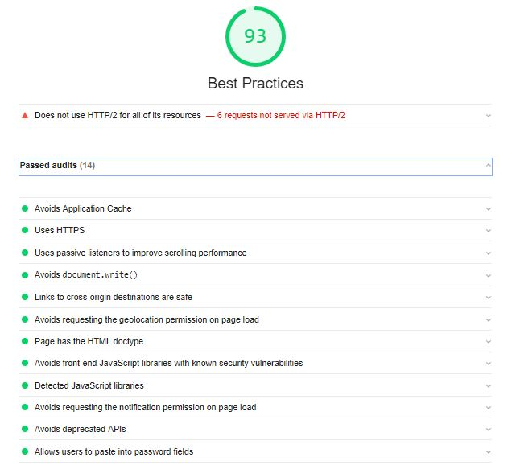

CONTACT PAGE-TESTING RESULTS
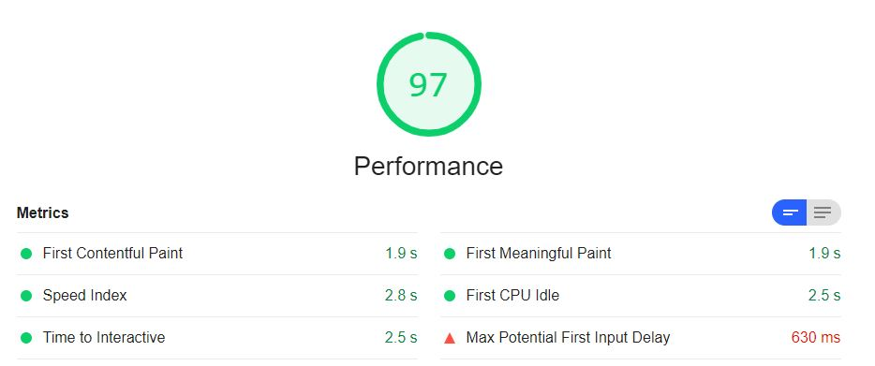

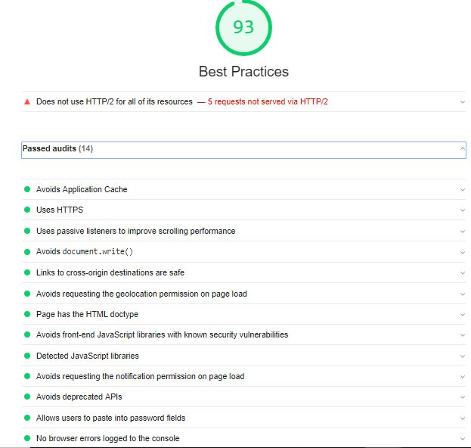
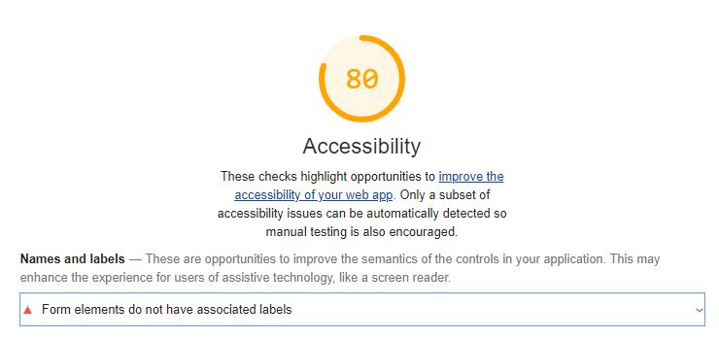
THEME PAGE-TESTING RESULTS
